**CHAPTER I**

**THE PROBLEM AND ITS BACKGROUND**

**Introduction**

Education has and will continue to be an integral part of an individual's intellectual, social, and moral development. For a long time there had been very few changes done with the ways and practices used to impart knowledge to students. But with the expanse brought by the emergence of technology it has introduced a new media that can branch out different possibilities for the various aspects of society. Nowadays, the use of the internet and technology has been a staple for almost everybody. Businesses are advertising across the internet, and communication has been enhanced dramatically because of social media, a new platform for entertainment and so much more.

Among these collective innovations and systems is Computer-Aided Instruction. Arnold [1] explained that Computer-Aided Instruction (CAI), also known as Computer-Assisted Instruction is an array of computer technologies dedicated to aiding the teaching and learning processes and comprises of various applications such as practical assessments and guided drills as well as computer-based teacher-and-student communication. This technology will provide a way for education to progress into a more advanced and interactive learning platform, which will then help potential users to use such technologies competently.

The skills and knowledge students can learn through education have also expanded by introducing the K-12 curriculum to the education system, even including computer knowledge into the curriculum to catch up with technological advancements. With these changes in place, it will increase the difficulty for the young students to learn a rather amplified learning curve. In relation to this, Palatino [2] stated in his article that lawmakers questioned the preparedness of the Department of Education (DepEd) in transitioning into a blended type of learning which will require them to conduct training, procure new learning materials, and the installation of internet connections during several hearings in the Congress and Senate.

So, in turn, it will seem as though that preschool education is almost a necessary preparation by developing basic motor skills that the children need before stepping into kindergarten and exposed to e-learning. On top of all this, the current pandemic has become a major hindrance to education and society as a whole. According to a survey conducted by the National Institute for Early Education Research [3], children within 3 to 5 years of age have lost their learning opportunities due to the pandemic.

This study will be conducted in the City of Cabuyao, Laguna and the proposed system in this study will be aimed towards preschoolers in order for them to have access to preschool knowledge through online means. The concurrent shift in the educational system and other external factors, especially the pandemic, has proved that teaching outside of schools' premises will be a challenge. Most schools within Cabuyao have also adapted to online communication platforms in order to connect and teach students virtually. But even with an alternative like this, younger students, often need support from their parents in order to navigate through computers or smartphones for their studies.

With this study, the researchers aim to utilize the versatility of CAI technology in providing support for preschool education using the curriculum intended for preschoolers provided by the Department of Social Welfare and Development (DSWD) online while also integrating entertainment aspects targeted towards the learners in order to keep them engaged in their studies without sacrificing the amount of knowledge that they shall acquire in using this technology which will ensure a fulfilling learning experience.

**Statement of the Problem**

The study aims to develop an online Computer-Aided Instruction for Public Preschool Students in the City of Cabuyao. It seeks to answer the following questions:

1. What are the current practices and problems posed by traditional teaching to the pre-school teachers with regard to:
   1. keeping children engaged with the lessons;
   2. assessing children's knowledge;
   3. measuring children's cognitive ability; and
   4. generating reports?
2. How would the proposed system be designed and developed in such a way that it would;
3. provide play-based learning materials and activities;
4. provide online graded assessments;
5. apply adaptive learning concepts; and
6. provide automated report generation?
7. What is the web development expert's assessment on the proposed system in terms of;
   1. functionality;
   2. usability;
   3. efficiency; and
   4. maintainability?
8. What are the parents’ and teachers’ assessment on the proposed system in terms of;
   1. functionality;
   2. usability;
   3. efficiency; and
   4. portability?

**Conceptual Framework of the Study**

This study aims as the researchers illustrate what will be the output of the proposed system.

|  |  |  |  |  |  |  |  |
| --- | --- | --- | --- | --- | --- | --- | --- |
| **INPUT** | |  | **PROCESS** |  | **OUTPUT** | | |
| **Knowledge Requirements**   * Preschool Curriculum * Web-based Programming Skills * Database Management Skills * Human-Computer Interaction skills   **Software Requirements**   * Visual Studio Code * Xampp * Adobe Software   **Hardware Requirements**   * Personal Computer,   2.6 GHz Processor, 4GB RAM | | **Scrum Agile Methodology**  **Scrum Events**   * The Sprint * Sprint Planning * Daily Scrum * Sprint Review * Sprint Retro perspective   **Scrum Artifacts**   * Product Backlog * Sprint Backlog * Increment | **Web-based Computer-Aided Instruction for Preschool**  **Students** | | |
|  | Evaluation | | | | |  |

**Figure 1. The Conceptual Framework of the Study**

The following evaluation needed from the proposed system is composed of input, process and output. The knowledge requirement is based on the Preschool Curriculum of the researcher's client. The researchers will use web-based programming tools such as JavaScript, JQuery, and PHP for the programming languages and CSS mainly for web design. Database management skills are necessary for this proposal as it will help to manage the data effectively. Lastly, human-computer interaction skills should be applied to this system since the researchers must have knowledge about the fundamentals of good design and the usage of computer technologies that focus on the interaction between people and computers.

The software requirements include Visual Studio Code, Xampp, and Adobe softwares such as Adobe Photoshop, Adobe Illustrator, and Adobe Animation. Visual Studio Code will be used as the main platform for coding. Xampp is an essential requirement for web-based programming since it allows PHP and MySQL Databases to function. Adobe Photoshop and Adobe Illustrator will be used in the designing the Computer-Aided Instructions by creating the background items and graphic illustrations to be used as the Preschool materials. Lastly, Adobe Animation will be used to create animations for a more dynamic presentation of learning materials that will help convince the users.

The hardware requirement will be a personal computer that runs on a 2.6 GHz processor and at least 4 GB of RAM to run most of the soft wares mention prior without experiencing issues.

In the process, Scrum agile methodology is a project management system that emphasizes iterative and gradual growth, with requirements and solutions emerging from cross-functional collaboration. According to an article written by Schwaber and Sutherland [4], the Scrum Events- First, there is the Sprint, which is the key component of the scrum where concepts are converted into value and all of the work required to meet the product target is completed. Second, Sprint Planning, which outlines what will be achieved and how it will be accomplished during the sprint. Third, Daily Scrum; to review progress toward the Sprint Goal and, if necessary, adapt the Sprint Backlog and upcoming scheduled work. Fourth, conduct a Sprint Review to assess Sprint's performance and make suggestions for possible improvements. The fifth step is to conduct a Sprint Retrospective in order to develop strategies for enhancing quality and performance. There is a product backlog for Scrum Artifacts, which is a list of what needs to be done to enhance the product. The sprint backlog is the collection of selected product backlog items to complete in a sprint. Finally, the increment represents a concrete step toward meeting the Product Target.

The output, "Online Computer Aided Instruction for Public Preschool Students" will be obtained once the Input and Process are acquired. With this Input-Process-Output or IPO being completed, the researchers can help solve the problem that the modern education encounters.

**Significance of the Study**

This study to be conducted by the researchers pose great significance to the transitions needed on improving the ways in which education is presented to the students. With the premise of introducing a platform in which a student can learn from an intuitive system designed for preschool learning. This will enable the researchers to gain further knowledge into developing education based systems for preschoolers which can be used as a foothold for further researches regarding more digital learning systems.

The researchers aim to procure a solution to distance learning in order to keep the flow of learning constant. With a crisis much like the pandemic, a large majority of teachers within educational institutions will have difficulty shifting onto digital platforms for teaching. Preschool students will also be affected whose learning opportunities are hindered by such crises. To develop an alternative way of learning for these students will be able to give solutions to the problems to be faced by the people this research is being done for.

This study will hold great significance towards schools, teachers, students, parents, IT students, the researchers, future researchers, and education system.

**Schools**. The schools that offer preschool education will gain a new alternative teaching mechanism for their preschool students. It will also diminish a significant amount of resources expended by their staff in modular learning, which will benefit their institution greatly, especially during a crisis like the pandemic.

**Teachers**. Teaching preschool students based on the curriculum will be more accessible with interactive visual learning materials that can be accessed through the system. It will also not require physical materials for lessons as it can be updated within the system.

**Students**. The interactive aspect of the system will provide an alternative way of learning other than modular learning and assessments. It will also immerse the children more into the use of technology and learning through entertainment-based teaching. Learning tasks will also be flexible in such a way that the students will be able to redo them to enhance their cognition and knowledge.

**Parents**. With the system designed in a way that children can comprehend and interact with on their own, it will lessen the occurrence of parents continually having to teach their kids regarding their lessons. It will diminish the challenges faced by parents in teaching their kids since the system acts as a learning guide based on their teacher's lessons.

**IT Students**. IT students will gather concepts and methodologies applied to the system as additional knowledge that will eventually help their course.

**Researchers.** The study will also benefit the researchers as they can gain a substantial amount of knowledge and improve on different skills that require them to conduct this study and use it in the future.

**Future Researchers**. This study will be able to provide findings that will be valuable for future Computer-Aided Instruction research and other related researches done in the future.

**Education System.** This study will be beneficial to the current education system since they can use it as reference in developing an alternative learning tool in the future.

**Scope and Limitation of the Study**

This study aims for the development of an Online Computer-Aided Instruction for Public Preschool Students here in Cabuyao. The purpose of this study is to provide an online platform that uses interactive learning activities for the preschoolers with ages ranging within two to five. This will also help immerse the students with their lessons with the use of interactive and straightforward aspects that they can easily navigate through with minimal provisions from their parents. Lastly, this study will also help preschool students to have an alternative in conducting lessons during crises like the pandemic. With this, the researchers aim to help solve the problems encountered in modern education.

The development of the system will be held in the City of Cabuyao. As a short background of the city, Cabuyao came from the word *"*Kabuyaw Tree*"* which is common in primary and secondary forests throughout the Philippines and native to the archipelago [5]. The city of Cabuyao has a large number of schools based on the website of Department of Education Cabuyao. The said research will be ended approximately six months or more. There are various features included in the system that help the users to navigate through it easily.

For the administrator's portal, the management of the subjects for students is present, which lets them modify the subjects based on the curriculum for daycare students provided by the Department of Social Welfare and Development (DSWD) that the students will have access to. It allows for a dynamic way of adding new subjects for the students to access, editing the currently existing subjects for possible revisions, and deleting subjects rendered obsolete due to certain circumstances. They can also manage the topics within specific subjects which has the same functions as the subject management.

The administrator’s portal also allows for the management of the frequently asked questions and announcements to be posted in the system.

Student management subsystem is a feature that will be included in the administrator's portal wherein the administrator can manage all the students information.

The student management for the administrator allows for the viewing and editing the students’ information. A search feature can be used to search for a specific student for easier navigation.

A video room is also included in the adminsitrator’s portal wherein they can add educational videos categorized based on the lessons that will be provided. They can also play the videos int their portal, delete the uploaded videos or edit the details of the videos. A search feature using keywords or categories will also be present for easier navigation.

A message box feature is also included in the administrator's portal wherein the administrators will be able to send messages to the parent's portal about upcoming tasks or assessments for their children, update the parents about their children's overall progress, or relay important announcements made by the school. It also lets them receive feedback or concerns from the parents.

Moving onto the parents section, child information management allows the parents to create multiple student profiles for their children whom they will allow to use the system. It also allows the parents to modify the personal information for possible corrections in the profile creation. Since discrepancies with the student information being a possibility, the same feature is present in the administrator's section enabling them to edit the information in cases that the parent's input is incorrect. Viewing the student progress reports is also a feature in which the parents are able to view the daily activity reports that contains the activities,trial quizzes, or assessments done in a day and weekly activity reports that encompasses all the activities, trial quizzes, and assessments done within a week to keep track of their child’s progress.

A timetable is also included in the parent's section wherein they can monitor the activities done by their children or print a copy if they wish to do so.

A message box feature is also included in the parent's section wherein they can contact the administrator about their possible concerns or feedback. It also allows them to receive announcements or about upcoming tasks and assessments posted by the administrators.

As for the students, there is a dedicated homepage that they can access after the parent selects the student profile corresponding to their child enabling them to enter the page. The home page is comprised of multiple subjects they can access to which are progressively unlocked once they meet a certain criteria.

There is also a subject page for students to access. This feature allows the students to navigate through their subjects wherein they can engage with learning activities specific to the selected subject. Learning tasks will be present in this feature which the children can use to learn about the topics on that particular subjects. The interface dedicated to each subject will vary depending on how the design will improve the children's willingness to interact with tasks presented in the system.

An assessment page is also present under each subject which will be posted by the administrators. These contain graded assessments that will test the student's proficiency and knowledge of topics prior to the learning tasks. Completion of such assessments will unlock the subsequent topics that the student's will learn next.

The programming language of the proposed system will be focusing on the web development tools such as HTML, CSS, JavaScript, Laravel, and Bootstrap. The system will also use dynamic programming tools such as PHP, MySQL DBMS.

HTML (Hyper Text Markup Language) will be used to display a web page's words and images from the browser. It is an essential programming language since it shows the output of the developer.

CSS (Cascading Style Sheets) is a tool that will be used to specify how HTML elements should be presented in a browser. CSS will enhance the look and feel of web pages, including the design, layout, and display variations for various devices and screen sizes.

JavaScript, on the other hand, is a web development scripting or programming language. JavaScript will be used to add complex features to web pages including content changes, interactive design, and animations.

PHP (Hypertext Preprocessor) is a scripting language that is especially suited in web development and can be implemented in HTML. PHP will be the most used language in terms of Computer Aided Instruction since PHP is applicable in adding dynamic content to be added in MySQL Database.

MySQL (Structured Query Language) is an open source Relational Database Management System. The main purpose of MySQL is store the database since the proposed system requires of adding the important contents to be added in Computer Aided Instruction.

Laravel is an open-source PHP framework that is both sturdy and simple to use. It adheres to the model-view-controller design pattern. Laravel reuses existing components from other frameworks, which aids in the development of a web application. The resulting web application is more structured and functional.

Bootstrap is a CSS Framework that will be an important part of the system since the proposed system should be responsive in any devices.

The other technologies to be utilized in the system will only be an extension of the webpages and as a part of Human Computer Interaction design materials.

Adobe Software such as Adobe Photoshop, Adobe Illustrator and Adobe Animation will be used to create vector materials and simple animation to be applied in the system.

The concept of Computer Aided Instruction will serve as a learning tool for the children without the supervision of teachers. The researchers will be responsible for the User Interface of the proposed system. The main interface shall be effective with the end-user's perspective. The said interface shall be clear, concise, familiar, responsive, and attractive. The User Experience will also be a factor to the research since it reflects the overall system. The experience will be interactive and efficient. However, this concepts will be effective once the researchers applied the Human Computer Interaction factors such as Task Factors, Environmental Factors and Comfort Factors on the proposed system.

The proposed system will be using a Scrum Agile Methodology. Scrum is a subset of Agile which is the most used one. Scrum is designed to assist teams in adapting naturally to evolving environments and customer needs, with built-in re-prioritization and quick release cycles to ensure the team is continually learning and improving.

Web Developers as well as Teachers and Parents will be the important evaluators of the proposed system. The two evaluators will be tasked to evaluate the proposed system. The evaluators may differ in their proficiency in using such systems which will possibly produce different outcomes. The Web developer must be a graduate of Bachelor of Science in Information Technology (BSIT) and have at least five years of experience in web development area and will evaluate the system in terms of capability, accessibility, and maintainability. On the other hand, the teachers and parents will evaluate using a client side perspective mainly focusing in its usability and intuitiveness.

Lastly, there will be limitations in development of this proposed system. The researchers are limited to using a curriculum provided by the Department of Social welfare and Development (DSWD) for preschool students in daycares. The learning materials to be used in this will be based on the mentioned curriculum catered to public preschool students.

**Definition of Terms**

|  |  |
| --- | --- |
| **Computer-Aided Instruction** | refers to instructions presented via a computer used to enhance teacher instruction. |
| **Blended-learning** | is a style of education where students can learn through digital and online media together with face-to-face learning. |
| **Modular-learning** | a form of distance learning that utilizes modules used for self-learning provided by the Department of Education. |
| **Assessment tasks** | are instructional strategies used to assess a student’s proficiency on a specific course. |
| **Learning tasks** | are interactive tasks that keeps the students engaged with the content being taught. |
| **Portability** | the ability of software to be transferred from one machine or system to another. |
| **Scrum** | is a framework within which people can address complex adaptive problems, while productively and creatively delivering products of the highest possible value. |
| **Sprint** | They are fixed length events of one month or less to create consistency. |
| **Sprint backlog** | it is a highly visible, real-time picture of the work that the developers plan to accomplish. |
| **Product backlog** | is an emergent, ordered list of what is needed to improve the product. |
| **Increment** | is a concrete stepping stone toward the goal of the product. |
| **Sprint review** | its purpose is to inspect the outcome of the sprint and determine future adaptations. |
| **Sprint retrospective** | its purpose is to plan ways to increase quality and effectiveness. |
| **Daily scrum** | its purpose is to inspect progress toward the goal and adapt the Sprint Backlog as necessary, adjusting the upcoming planned work. |
| **Preschoolers** | Children ranging from ages 3 to 5 years old. |

**CHAPTER II**

**REVIEW OF RELATED LITERATURE AND STUDIES**

This chapter basically shows the sources of research and literature. The information in the studies are both foreign and local researchers which may essentially help with the research. This is required for researchers to gain a more comprehensive knowledge in the study.

**Education System and Issues**

Education has always been an essential factor towards life improvement. In the Philippines, the education system is still developing. According to [6] the first stages of Philippine Education were informal, unstructured and devoid of methods. The majority of development of the system of education started during the Spanish colonization [7]. During this era, the education was religion-oriented until independence starts in 1946 due to United States colonialization [6] – [7].

The Philippines had an 11-year basic education period consisting of grades 1 to 7 and four years of high school [7]. Following the war, the American colonial government recommended a conversion to the American system: six years of elementary school (rather than seven), three years of junior high school, and three additional years of senior high school, for a total of 12 years of basic education. The transition started with the end of Grade 6, but the two-year extension to high school was never completed. Balansag [8, p. 2] stated that it has been the goal of the Philippine education system to innovate curriculum into globally competitive structure.

In 2012, the curriculum of K-12 in the Philippines was introduced, after the progress of the Kindergarten Act and the Enhanced Basic Education Act in the same year [9] – [10]. In 2013, the Department of Education facilitated several of trainings to the teachers. As mentioned by Alsubaie [11, p. 107] that teacher involvement is important for successful and meaningful curriculum development. Teachers being the implementers are part of the last stage of the curriculum development process. In relation to [8, p.2], it is evident that teachers are also part of the innovative curriculum.

However, in the year 2020, Gayo and Yap [12] mentioned that the world has encountered a new virus named "SARS-CoV-2" with the strain's similarities to the SARS-COV and later on the disease is called "Coronavirus Disease 2019" (COVID-19). For almost two pandemic months, most countries around the world have temporarily closed educational institutions to contain the spread of the COVID-19 pandemic and reduce infections [13]. Crawford et al. [14] noted responses like community lockdown and community quarantine of several countries had led students and teachers to study and work from home, which led to the delivery of online learning platforms. The implementation of online learning posed different risks, problems, and challenges to both the teachers and students, especially in the higher education institutions (HEIs) [15, p. 141].

However, besides the fact of [15, p. 141], Preschool education, on the other hand, is interrupted during pandemic because there are no related programs and because such programs would have to be child-centered, not subject-centered [16]. Although, as stated by Burgess and Sievertsen [17] and Viner et al. [18, p. 397 - 404] some studies have investigated the effects of outbreaks on education, there is no research on how to carry out preschool education during outbreaks, causing uncertainty for preschool teachers and parents. As a result, more studies should be done to guide preschool teachers and parents in collaborating to achieve sustainable preschool education during pandemic.

**Children Learning Development and Psychology**

Taking into account the capabilities of children when it comes to using the proposed system, further research is conducted regarding a child’s cognition and learning process. Childhood is truly a delicate stage in growth and development as a person. According to [21], there have been great evidences from various other studies that skills that increase positivity, resilience, engagement and meaning can be taught and attained by schoolchildren at a very young age. This may be the motivation for other researchers to try and make sense and have a better understanding of the development of children. [19]The role of children’s early skills in charting later developmental trajectories has been archived across a wide range of study. This solidifies the idea that the development of skills amongst children play a great role in their future.

There are also theories pertaining to the factors affecting the ways in which a child learns and grows. [23, p. 7]There are developmental theories which dabbles upon the changes in the child resulting from interactions between growth and learning as well as the behaviorist theories which emphasizes learning with the changes happening in the environment. And because children tend to be enrolled to schools for earlier education, there are more factors that even teachers need to consider in order to ensure the proper learning of children. [22] The children’s readiness, classroom environment, methods of teaching, assessments, and teaching aids are multiple factors needed in order to provide an effective simulative teaching and learning environment.

Children are constantly engaged in making sense of their surroundings and sharing their perspectives. Play-based learning aids in the development of social skills, motivation to learn, and even language and numeracy skills in children. Piaget saw play as essential to the development of children's intelligence. According to this play theory, as a child grows older, their environment and play should encourage further cognitive and language development [27]. Based on the study of Pardue [25], it reveals significant differences in the definitions of “child-directed” and “playbased” learning among Filipino preschool directors and teachers, and it also identifies apparent cultural barriers to more effectively implementing child-directed learning. According to the findings of [26], public school educators describe play as a tool for learning, enjoyment, exploration, and motivation. The participants demonstrated complete understanding of the benefits of play to the development of the physical, mental, and emotional aspects required for learning.

And since the emergence of technologies into the norms, it has paved new ways for teaching and learning using new media contributing to the factors affecting the learning process of the students. Tied up to this is the correlation of entertainment to the modern era which can be utilized as a means to create an interactive learning environment appealing most especially to the younger students. According to [20], it is very important to understand the children’s needs and create visionary interactive systems designed to the enhancement of education and entertainment. Knowing how to deliver corresponding features that would enable quality learning on specific target areas makes the difference in the development of the child’s skills and knowledge. As stated in [24], combination of interactions with varied sensory and cognitive stimulations may have the potential to have positive or negative impacts on attention, fine motor control and other cognitive domains. This proves that the design of such systems shall be intricate enough to mesh early education with entertainment in order to make a reliable end product.

**Transition of Learning in the Philippines**

Traditional teaching was the long-established teaching style in Philippine education system wherein the students are passive in terms of participating in class **[**8, p.2**]**. Live interaction makes it easier for students to communicate easier with their teachers, rendering study-related matters and inquiries are easily addressed [28]. The way in which traditional methods were taught ensured that students were rewarded for their efforts, used class periods efficiently and exercised clear rules to manage students’ behavior [29]. They were based on established customs that had been used successfully in schools over many years. In relation to [22], it is evident that traditional learning is essential in terms of teaching children.

Traditional learning has been the most common method of teaching and learning among educational institutions. However, there are downsides with traditional learning that may hinders the students learning. As stated by [8, p.2**]**, the education should be developing. Since were in the 21st century, the educational system adapting to digital learning is essential. [30] Singapore, Taiwan, Hong Kong, Japan and other parts of Asian countries have already advanced their technological capabilities in terms of the delivering quality instructions. Nevertheless, Philippines is on experimental stage in the development of digital learning [31].

Traditional learning in the Philippines is starting to disappear and faces challenges in access towards distance learning [32]. Although it is practiced all over the world, it is losing its prevalence. [33] Stated that, country is developing and becoming a part of a digital revolution where education is mostly based on digitized education. Technology has been proven to be very helpful in educating student. Visual presentations, educational videos, interactive programs, learning tutorial and variety of books available all the time on internet has revolutionized education in a better way [34].

In addition, COVID-19 has been a huge factor in transition of learning system. According to Toquero [35], there is a stronger need for academic organizations to improve their curriculum and the usage of new instructional methods and strategies should be of utmost significance. In relation to [8] and [31], the Philippines is still adapting the fundamentals of online learning that will be used in this time of pandemic.

**Computer Aided Instruction and Adaptive Learning**

Computer-aided instruction (CAI) is the interactive and instructional presentation of various forms of educational media material. The use of a computer as a method to promote and enhance instruction is known as CAI. Ruliah et al. [36] have noted CAI programs address topics through lectures, drill and practice, simulation, and problem solving, and they assess the student's comprehension. Nowadays, teachers have access to technological applications that can help them improve the effectiveness of their teaching and learning. One of the technologies is computers that can be used in the learning process.  Some instructional approaches are computer-assisted and can be accessed through a computer.  CAI-based teaching materials, according to [37] are a type of content delivery method that uses a variety of media to educate students. A computerized framework is used to design and configure the interactive media. As shown by [33], CAI can be utilized to assist in the design, analysis and manufacturing of products in teaching delivery which involves text and image identification for kids under the ages of 2 to 5 years to improve their learning.

Computer-aided instruction appears to be a perfect method, it does have some drawbacks. [39] The cost of computers, electronic devices, and software is high. As a result, providing a computer for each student is simply not a feasible target. [40] It is difficult to motivate and prepare teachers to use computers in class. They can be apprehensive about this new device. They may be hesitant to devote additional time to CAI planning, collection, and application. [41] On the other hand, teachers can lead the way by preserving personal relationships, creating new habits, reimagining timelines, and providing additional help to students. They may not be able to reproduce classroom instruction in the event of a pandemic, but they can definitely use resilience and fortitude to keep students learning in the days ahead.

Although there are drawbacks in implementing CAI, the benefits of CAI will greatly outweigh those disadvantages. Computer assisted learning has the potential to completely transform the educational process and significantly increase learning efficiency by providing children with a sense of purpose. According to Sharma [40], CAI is individualized, meaning that each student is free to work independently of the performance of other students. In addition, [42] CAI also assisted preschoolers in learning interactively through the lessons presented and in recapitulating what they had just learned. Funcion et al. [44] mentioned that CAI can also provide a more adaptable, creative, and enjoyable environment for pupils' learning experiences. Shamir et al. [43] stated that students who used the CAI program has highest score on the tests, implying that the positive impact on academic performance would have been much greater if the software had been applied with minimal usage expectation for all students. As long as the benefits and drawbacks are controlled, using CAI can be an excellent way to incorporate new technology and enhance the learning experience.

In developing a CAI, adaptive learning will be used to fortify the learning progress of the users in using such systems. Adaptive learning, also known as adaptive teaching, is the delivery of custom learning experiences that address the unique needs of an individual through various means. By doing activities that apply adaptive learning, the user's progress will determine the occurrence of adaptive teaching like just-in-time feedback, etc. The [45] supports this as it states that adaptive learning activities can adjust in real time to a learner's needs, encouraging the development of higher-level abilities such as combining information from many fields to solve real-world situations. This implies that guiding a learner's capability with real time assistance helps them develop and apply such knowledge gathered into the real world.

In the subject of learning, educational games especially those dedicated for children often use adaptive learning as a way to train the users in playing the game. According to [46], adaptive games are considered superior over non-adaptive games due to the fact that the children's performance are assessed constantly and adjust the difficulty of activities to match the children's individual level. This shows that adaptability towards learning even in educational kids games shows great influence in the improvement of the children's performance.

There are also factors to consider for adaptive learning in order to successfully implement it. Directly quoting from [47] it explains that '(1) apart from learners’ cognitive ability, it is important to consider affective factors such as motivation in adaptive learning, (2) lack of alignment among various components in an adaptive system can impact how learners accessed the system and, more importantly, their performance, and (3) visualizations can reveal interesting findings that can be missed otherwise.

**Synthesis of the study**

With the related literature that tackled about the education system especially in the Philippines, there is a slow grasp on the changes happening towards the curricula and methods of learning that are being adapted by the nation's educational system. The teachers are also found to be an important media for the student's learning and the Department of Education recognizes this and conducts trainings that will enhance and develop the skills they need in teaching either traditionally or virtually. And because the pandemic struck, it has pushed schools to shift to online learning platforms which was an abrupt change in the pace of the delivery of education which affects preschool education badly because there is no guaranteed solution that enables the preschoolers learning in a rather complex online platform. Taking this into account, researches relating to a child's cognition, psychology and learning process is also explored in order to makes sense on how to approach the proposed CAI for the preschool children.

The children's thinking and learning process proved to be relevant in various researches in explaining the relevance of a child's skill and knowledge development in their later trajectories in the future. There are also theories that factor in the interactions and learning environment of a child affecting their cognitive development. There are also factors pertaining to play as a means of learning which upholds an entertainment based learning dedicated for the children in preschools as well as the teacher's and their way of teaching and presenting learning materials to engage their students.

Understanding the premise of traditional learning towards students is essential in order to gain knowledge of the process together with the advantages and disadvantages posed by this method of learning and use the information to come up with a solution to enhance the learning experience with the implementation of an online medium that aids learning. The traditional way of learning has ensured an effective way in managing the student's behavior as well as their academic performances with the help of live interactions which bridges communication between the teacher and the students with regards to study related matters. Even with the effectiveness by this method of learning, expanding the media in which a children can learn is a must in order to cope with the worldly advancements in education.

Extensive research regarding the CAI together with its development, advantages and disadvantages is done to gain a better grasp in preparation for the development of the proposed CAI system dedicated to preschoolers. CAI is defined as a tool that helps aids learning by presenting instructional materials with the use of computers. And, with the abundance of digital media, educational institutions should be able to train the teachers to adapt to a more flexible medium of teaching the students. There are also drawbacks with the use of CAI like the preparing the teachers in using the computers to assist them in teaching which shall be taken into account in order to be able to create an interface correlating such concerns. The concept of adaptive learning is also established as well as the factors that tie in with the overall learning progress of the students.

**CHAPTER III**

**METHODS AND PROCEDURES**

This chapter explains the procedures needed to be used in research. This chapter discusses the research design, respondents of the study, data gathering tools, data gathering procedures, and system development which is essential to the study. This describes the procedure that must be followed in order to create the flow of system.

**Research Design**

The researchers followed a series of steps to arrive at the main target or objective, which was done by the practical understanding of a suitable technique. This part of the study will discuss the procedures to be used by the researchers to be able to acquire the needed data and details for the study. Furthermore, the output of the research will be fully developed once fulfilled.

Quantitative and Qualitative data will be collected on the research in short, the researchers will be integrate a mixed method of data collection. The researchers will be using a descriptive type of research to gather information. Descriptive research wherein details are accurately collected without altering their background. The analysis of the population sample will help in the formation of the system.

The descriptive type of research is an appropriate choice for the topic since this investigates one or more variables. In contrast to experimental research, which the researcher does not influence or manipulate the variables, but rather observes and measures them.

**Respondents of the Study**

To gather the necessary data, the researchers will use a non-probability sampling technique. Purposive sampling is a sampling method which enables the researchers to choose their own sample from a population. This method of sampling will be used for its convenience especially during this time of pandemic. According to [48], the sampling design is based on the judgment of the researcher as to who will provide the best information to succeed for the objectives of the study. By using the strategy, the process has the advantage of being time-saving and effective with the study.

Consequently, the researchers want to access a particular group of people that will be needed with the researchers’ study.

**Table 1. Respondents of the Study**

|  |  |
| --- | --- |
| **Respondent Category** | **No. of Respondents** |
| Users | 15 |
| Web Development expert | 10 |
| Total | 25 |

Table 1 shows the total number of the population of the given respondents needed for the study. It has three categories which are preschool teachers, parents or guardian of the preschooler, and web development experts.

The respondents of the study are comprised of fifteen (15) users and ten (10) web-development experts totaling into twenty-five (25) overall respondents. The users are composed of preschool teachers from Cabuyao City and parents and the chosen experts must have atleast five years of work experience as a software or web developer, exhibits prowess in programming and web design, and adept in the fields of software and web development.

**Data Gathering Tools**

The researchers will utilize multiple tools to gather important data which will help in the process of creating both the research and the system itself. Such data gathering tools shall be used to gather relevant information thus, aiding the researcher’s progress.

An interview is the activity between an interviewer and interviewee wherein an interactive conversational exchange between both participants in which the interviewer’s questions intended to gather information are answered by the interviewee. The interview will be used to garner relevant information in relation to the proposed system to be developed.

The internet contains a plethora of information about almost anything including many scholarly works. An internet research is to be conducted by the researchers in order to collect data from related studies posted on the internet. The information that will be gathered from the online based resources will be beneficial during the research.

A library research makes use of the articles, researches, and journals that are shelved and can be easily accessed in a library. Conducting a library research will also be useful to the researchers as they can browse for studies about computer-assisted instruction and education-based systems and other informative resources. Finding similar studies to the current research will be used as references to further improve on both the research and the system.

A survey is a set of questions with a choice of answers targeted at a specific population used to gather information from the respondents. The survey will be utilized to gather feedback from using the finished system.

**Data Gathering Procedures**

The researchers reached out to the client and contacted them through a social media platform. This was done to look for possible suggestions and recommendations with regards to the system to be developed.

The researchers then began to look for journals and related studies online with the use of their personal computers at home. Browsing the internet is used to collect reliable information helped in correlating supporting data for the research.

Even after the extensive search of related information on the internet, the researchers proceeded to go to the school library in Pamantasan ng Cabuyao. The purpose was to look for more reliable resources like previous studies and researches which prove to be more credible than other online references.

The researchers will then gather data from the respondents via a survey. The survey will utilize the Likert scale as its survey scale which is comprised of five possible responses on each survey item depending on the type of questions the researchers will impose on their respondents.

**Data Analysis Plan**

The data that will be collected from the survey shall be presented in a tabular format. The scale to be used for the survey is the Likert scale. The Likert scale assumes that the intensity of an attitude is linear and uses five to seven linear responses to assume the measure of an attitude. The survey will have five (5) options to choose from each with its corresponding numeric code as shown below.

|  |  |
| --- | --- |
| Option | Code |
| Strongly Agree (SA) | 5 |
| Agree (A) | 4 |
| Undecided (U) | 3 |
| Disagree (D) | 2 |
| Strongly Disagree (SD) | 1 |

In determining the average responses across the respondents, the median will be used to evaluate the average scores. The median and percentage will be used as the main statistical tools for tallying the responses from the survey.

**System Development**

The methodology to be used in developing the proposed system is the Scrum agile methodology. The Scrum agile methodology is a widely used framework in the development of system software that is both lightweight and easy to understand. It is composed of several phases which are Initiate, Plan and Estimate, Implement, Review and Retrospect, and Release.

During the Initiate phase, the researchers will have to create a summary of all the requirements and features that will be implemented to the proposed system. The overall design of the proposed system will be formulated by the researchers.

A class diagram is a type of diagram which is part of a unified modeling language (UML) that defines and gives the overview and structure of the system in terms of classes, methods, attributes, and the relationship amongst the different classes.

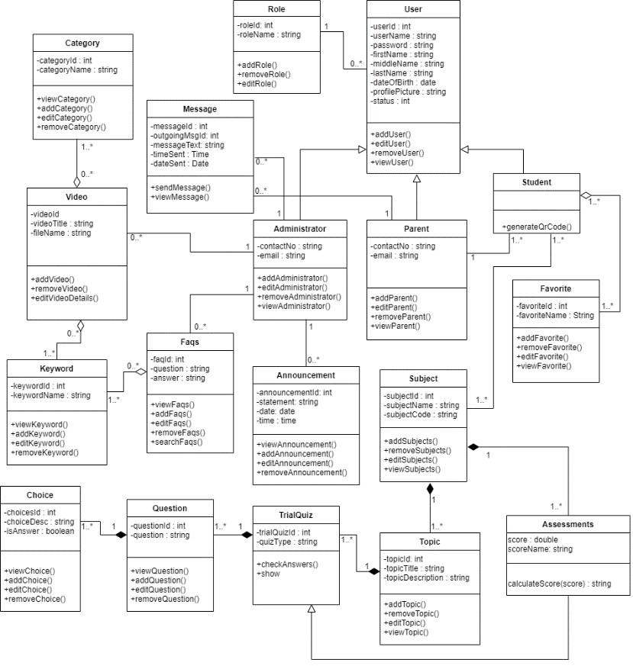**Figure 2. Class Diagram**

Figure 2 shows all the classes that will be used on the Online Computer Aided Instruction for Public Preschool Students and their corresponding methods and relationship with one another. The class diagram shows the user, student, parent, admin, roles, faqs, announcement, subject, topic, assessment, choice, question, trial quiz, video, category, keyword and message. It shows the various objects included in the proposed system, their relationships and multiplicity, and how objects interact with one another. The Class Diagram is made up of seventeen different classes that are interconnected.

In the Plan and Estimate phase, the researchers will start to layout the activities for the proposed system. The researchers will establish the design for every activity to be accomplished.

Use case diagrams are a visual representation of a system's requirements, including internal and external factors. The roles of the actors are portrayed across these diagrams. The purpose of this diagram is to provide an overview of the actors and their roles, functionalities, as well as dependencies presented in the diagram.

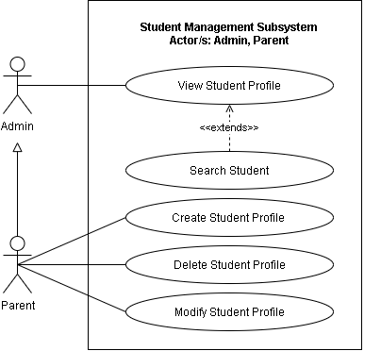

**Figure 3. Use case diagram for the Student Management Subsystem**

This shows the Use case diagram for Student Management Subsystem. The illustration shows the capabilities of Parent and Admin actors. The parent logs in to their account and navigates to the student management page. The parent can then select a function that lets them create a student profile for their children which require them to input basic information about their child and save it to the profile. The parent can also view a student profile by selecting a profile of their choosing or searching for keywords of a specific student profile which shows the details saved for that student profile. The parent can also modify an existing student profile by selecting the profile of their choosing and selecting a modify function which shows a form that lets them update the information and be saved to the said profile. The parent can also delete an existing profile by selecting a student profile and selecting a delete function which shows a dialog box that asks for confirmation wherein if confirm is selected, the profile will be deleted. The admin can only view a student profile by selecting a profile of their choosing or searching for keywords of a specific student profile which shows the details saved for that student profile.

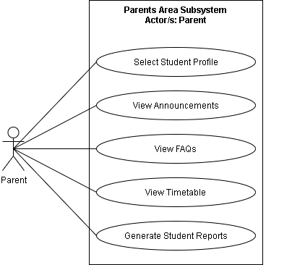

**Figure 4. Use case diagram for the Parents Area Subsystem**

This shows the use case diagram for Parents Area Subsystem. This illustration shows the capabilities of the Parent actor. The parent logs in to their account and they can select a student profile from the parent's area by clicking on one profile of their choosing. The parent can also view announcements posted by the admin by selecting a 'view announcements' function within the parent's area letting them browse through posted announcements. The parent can also view FAQs posted by the admin by selecting a 'view FAQs' function within the parent's area which lets them browse through frequently asked questions answered by the admin. The parent can also view timetable posted by the admin by selecting a 'view timetable' function within the parent's area which they can browse the timetable of various activities in a student profile.

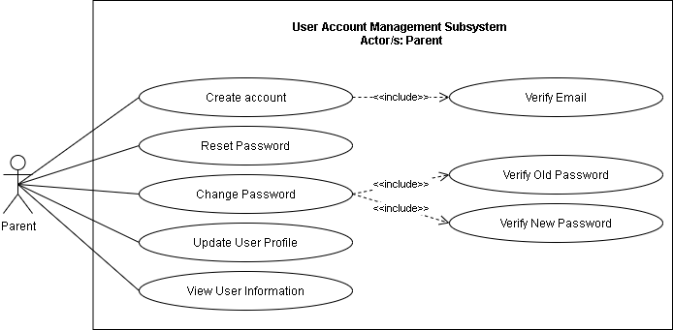

**Figure 5. Use case diagram for the User Account Management Subsystem**

This shows the use case diagram for User Account Subsystem. This illustration shows the capabilities of the Parent actor. The parent starts by creating an account by inputting the required details in a signup form and submits it to the system which triggers the system to verify the email address of the parent by sending a confirmation email which the parent can check the email and click the link to complete the verification and redirect them to the login page. The parent can reset their password by clicking a 'reset password' function that sends a reset password link through their email which redirects them to a form that requires them to input a new password to be saved for their account. The parent can also change their password by navigating through their profile and selecting a 'change password' function that opens a form that requires them to input the correct old password and a valid new password for verification before saving the new password. They can view their own information by navigating to their profile which shows all the details they inputted for their account. They can also update their information by navigating to their profile and select the edit function which opens a form containing all the information they want to edit and save it once they are done updating.

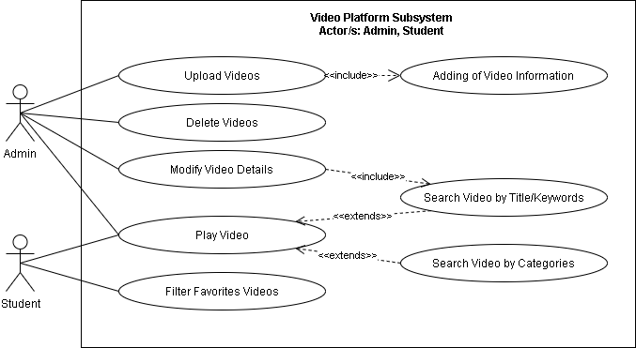

**Figure 6. Use case diagram for the Video Platform Subsystem**

The admin logs in and selects the 'upload video' function which opens a form wherein they can attach video files for uploading which requires inputting the information about the video before uploading. The admin can modify the information on an existing video by selecting an 'edit' function after searching for the video they choose through typing in the title or any keyword related to that specific video. The admin can also play an already existing video by navigating to the video platform and selecting a video from the video library and filter videos based on a category or search for a specific video by typing in the title or keywords relating the that video. As for the student, once the parent has given their child access to their student profile, the student can navigate to the video platform wherein they can play videos that is displayed in the library or search a video by typing in the title or keywords relating to that video or filter the videos by selecting a specific category. The student can also mark videos that they like as favorites by clicking an 'add to favorites' function present on each video.

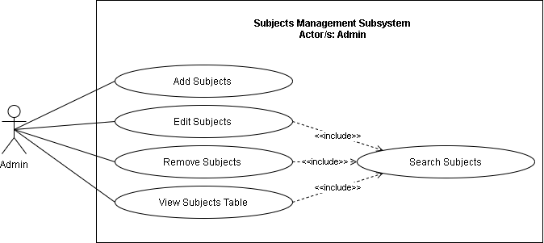

**Figure 7. Use case diagram for the Subjects Management Subsystem**

This shows the use case diagram for Subject Management Subsystem. This illustration shows the capabilities of the Admin actor. The admin logs in and navigates to the subject management section. The admin can then add new subjects to the system by selecting an 'add subject' function that opens a form to input the details for the subject to be added and saved. The admin can also edit information on an existing subject by choosing a subject by searching for the title or keywords relating to that subject and selecting an 'edit' function that opens a form to input the new information on a specific subject before being updated. The admin can also delete an existing subject by choosing a subject through searching for the title or keywords relating to that subject and selecting a 'delete' function that opens a confirmation dialog that when confirmed deletes the subject selected. They can also simply view a subject after searching for the title or keywords and selecting the subject found showing the details for that particular subject.

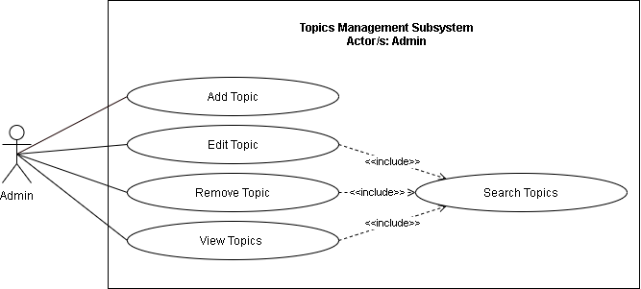

**Figure 8. Use case diagram for the Topics Management Subsystem**

This shows the use case diagram for Topics Management Subsystem. This illustration shows the capabilities of the Admin actor. The admin logs in and navigates to the topic management section after selecting a specific subject. The admin can then add new topics to the selected subject by selecting an 'add topic' function that opens a form to input the details for the topic to be added and saved. The admin can also edit information on an existing topic by choosing a topic by searching for the title or keywords relating to that topic and selecting an 'edit' function that opens a form to input the new information on a specific topic before being updated. The admin can also delete an existing topic within a subject by choosing a topic through searching for the title or keywords relating to that topic and selecting a 'delete' function that opens a confirmation dialog that when confirmed deletes the topic selected. They can also simply view a topic after searching for the title or keywords and selecting the topic found showing the details for that particular topic.

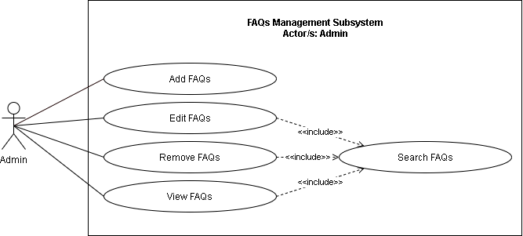

**Figure 9. Use case diagram for the FAQs Management Subsystem**

This shows the use case diagram for FAQs Management Subsystem. This illustration shows the capabilities of the Admin actor. The admin logs in and navigates to the FAQs management section. The admin can then post new FAQs to the system by selecting an 'add FAQs' function that opens a form to input the details for the FAQ to be added and saved. The admin can also edit information on an existing FAQ by choosing a FAQ by searching for the title or keywords relating to that FAQ and selecting an 'edit' function that opens a form to input the new information on a specific FAQ before being updated. The admin can also delete an existing FAQ by choosing a FAQ through searching for the title or keywords relating to that FAQ and selecting a 'delete' function that opens a confirmation dialog that when confirmed, deletes the FAQ selected. They can also simply view a FAQ after searching for the title or keywords and selecting the FAQ found showing the details on that particular FAQ.

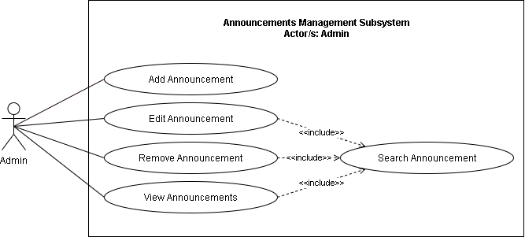

**Figure 10. Use case diagram for the Announcements Management Subsystem**

The admin logs in and navigates to the announcement management section. The admin can then post a new announcement to the system by selecting an 'add announcement' function that opens a form to input the details for the announcement to be added and saved. The admin can also edit information on an existing announcement by choosing an announcement by searching for the title or keywords relating to that announcement and selecting an 'edit' function that opens a form to input the new information on a specific announcement before being updated. The admin can also delete an existing announcement by choosing an announcement through searching for the title or keywords relating to that announcement and selecting a 'delete' function that opens a confirmation dialog that when confirmed, deletes the announcement selected. They can also simply view a announcement after searching for the title or keywords and selecting the announcement found showing the details on that particular announcement.

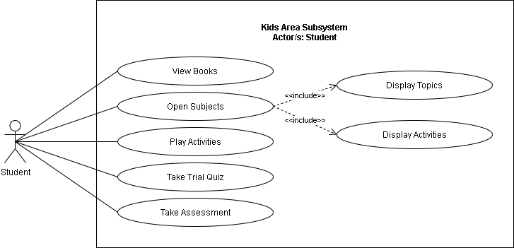

**Figure 11. Use case diagram for the Kids Area Subsystem**

After the parent selects the student profile for their child the student can access the kid's area which they can view books by selecting a 'view books' function showing a library of books that the student can navigate through and browse books from by selecting a book. The student can also open the subjects by selecting an 'open subjects' function that shows all the subjects they have and by selecting one, the topics and activities for the selected subject is displayed. The student can play activities by selecting an activity within a subject and interact with that specific activity. The student can also take iterative trial quizzes by selecting one from within a particular subject. The student can also take graded assessments from each topic within a subject by navigating through the subjects and selecting a specific topic then choosing to take an assessment for that particular topic.

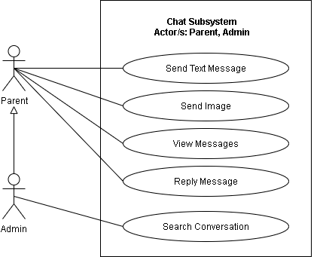

**Figure 12. Use case diagram for the Chat Subsystem**

The parent logs in and goes to the messages section. The parent can then send messages to the admin by selecting the conversation from the messages and typing what they need to say and send it the message to the admin triggering a notification to pop up in the admin side of the conversation. They can also receive messages which they can see by opening the conversation after receiving a notification. The parent can also browse through all the messages sent and received by opening the conversation and scrolling up to see previous messages. The parent can attach images and send it as a message in a conversation by selecting an 'attach image' function in the chat and send the image as a message after attaching the desired image file. The admin has all the capabilities the parent has in this subsystem with only the addition of searching conversations which lets them navigate through multiple conversations with parents with ease.

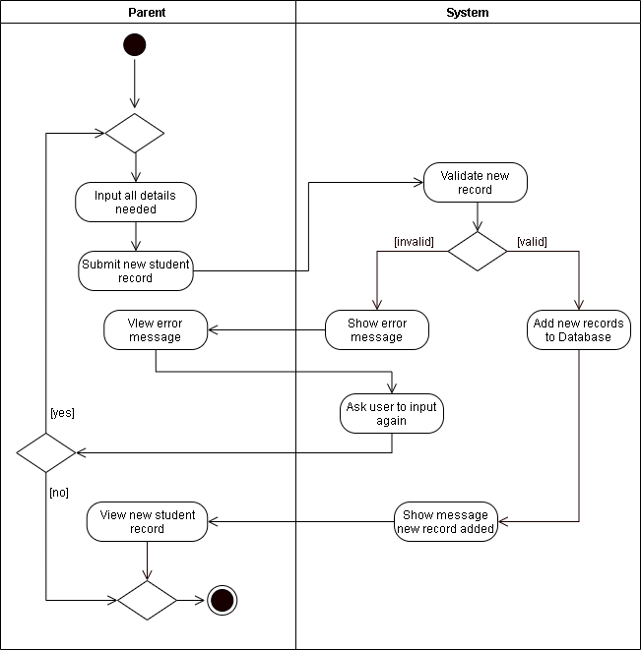

**Figure 13. Activity Diagram for Creating a Student Profile**

Figure 13 shows the activity diagram for creating a student profile. The parent will input all the information required for the student profile then submit a new student record. The system then validate if the inputs are correct and there are no records matching the new record. If the new record is deemed valid by the system, it is then added to the database and show that the new record was added and redirects to the view of the new student record. If the new record is deemed invalid, an error message pops up and allows the parent to choose whether to input again or not.

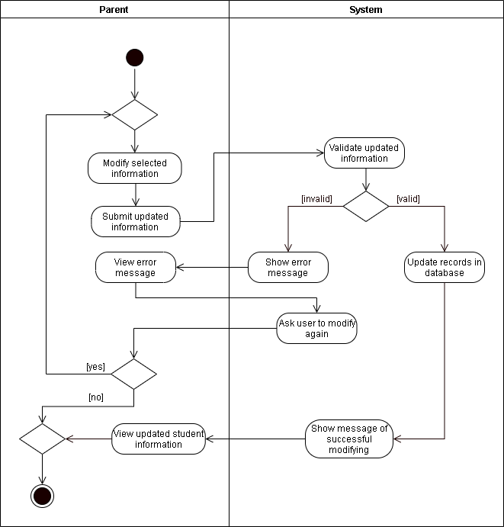

**Figure 14. Activity Diagram for Modifying a Student Profile**

Figure 14 shows the activity diagram for modifying a student profile. The parent navigates to the ‘manage student profile’ which displays the student profile/s of their children. They then will select a student profile they wish to modify which leads them to a form where they can update the current information in the profile. After updating using the form, they will submit the updated information which will then be validated by the system. If the information is deemed valid, the records of the database will be updated and show a message of successful updating of profile. If deemed invalid, they can choose whether to re-enter the information or terminate the action.

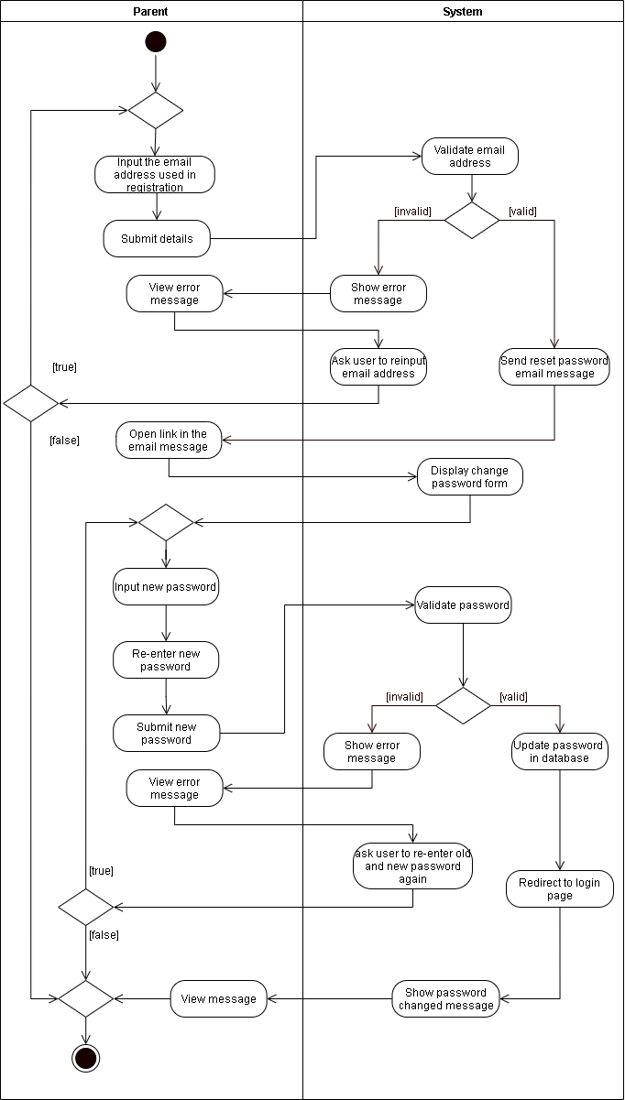

**Figure 15. Activity Diagram for Resetting the Password**

Figure 15 shows the activity diagram for resetting the password. The parent will be asked to input the email address they used for registration in order for the system to validate that email address. If the email address is deemed invalid, they can either choose to input another email address or terminate the action. If the email address is deemed valid, the system will send an email to the email address containing a link for the resetting of the password. This link redirects to a change password form where they can create a new password for the account and submit it for validation. If the entered password is invalid, an error message pops up and asks whether they would like to enter a new password or terminate the action. If the entered password is deemed valid, the password will be updated and redirects to the login page.

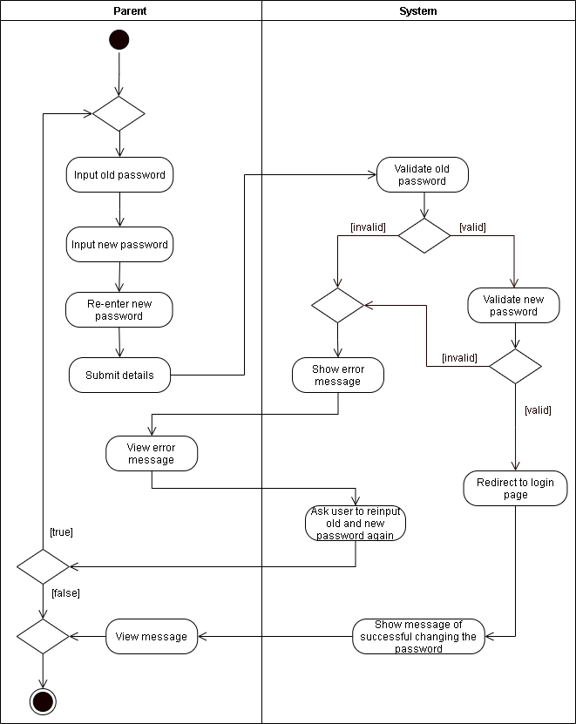

**Figure 16. Activity Diagram for Changing the Password**

Figure 16 shows the activity diagram for changing the password. The parent will need to input their old and new password which will be submitted for validation. If the old password is deemed invalid, an error message pops up and gives the option whether to do another input or terminate the action. If the old password is deemed valid, the system proceeds to validate the new password. If the new password is deemed invalid, an error message pops up and gives the option whether to do another input or terminate the action. If the new password is deemed valid, it redirect to the login page and shows a message of successful changing of password.

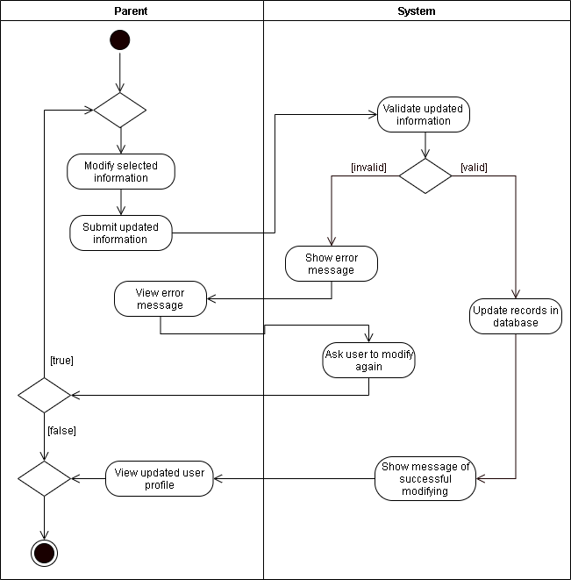

**Figure 17. Activity Diagram for Updating the User Profile**

Figure 17 shows the activity diagram for updating the user profile. The parent will modify and submit the updated information to the system for validation. If the updated information is deemed invalid, an error message pops up and gives the option whether to try another input or terminate the action. If the updated information is deemed valid, the records of the database will be updated and a message of successful modification and redirects to the updated user profile.

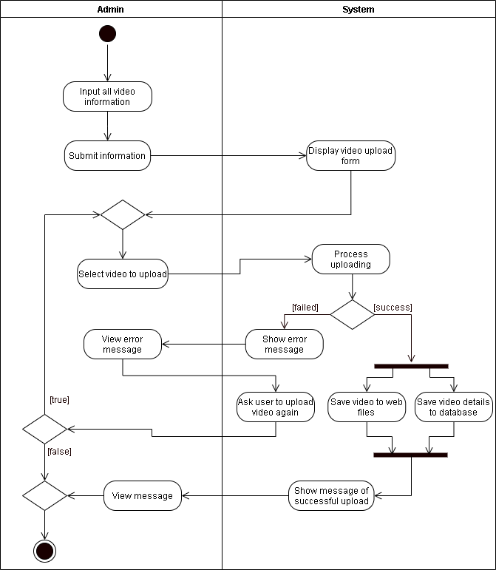

**Figure 18. Activity Diagram for Uploading a Video**

Figure 18 shows the diagram for uploading a video. The admin will input all the video information and submit the information to the system. Once the video is selected, the system will now process the uploading of the video. If the video processing fails, an error message will show and gives the option whether to try another upload or terminate the action. If the video processing succeeds, it will now be saved to web files and save the video details in the database at the same time.

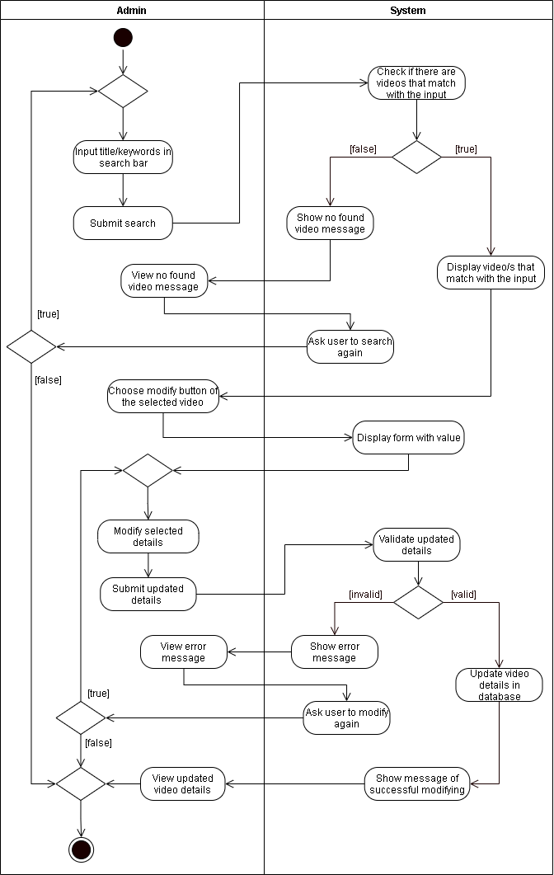

**Figure 19. Activity Diagram for Modifying the Video Details**

Figure 19 shows the Activity diagram for modifying the video details. The admin will input the video title or keyword in the search bar, if there is a video found, the system will display the video that matches the input and if not, the system will show that the video is not found. Next, the admin will select the modify button on the selected video that has a display form with value. After completing the form, the system will process updating the video details. If the video is valid, it will now update the details in the database. Otherwise, the system will show an error message and will be asked to recreate the process of editing the video or terminate the action.

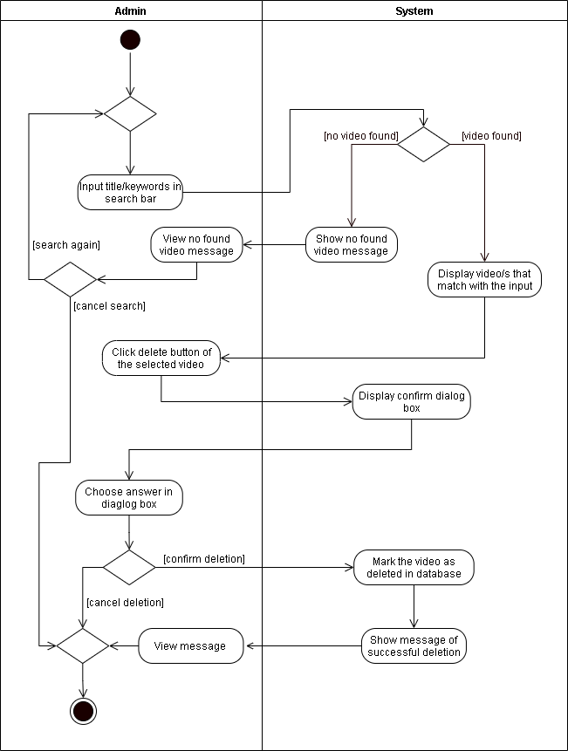

**Figure 20. Activity Diagram for Deleting a Video**

Figure 20 shows the Activity diagram for deleting a video. The admin will input video title or keyword in the search bar, if there is a video found, the system will display the video that matches the input and if not, the system will show that the video is not found. Next, there will be a delete button of the selected video that will display prompt. After choosing answer in prompt, the system will now remove the video in the database.

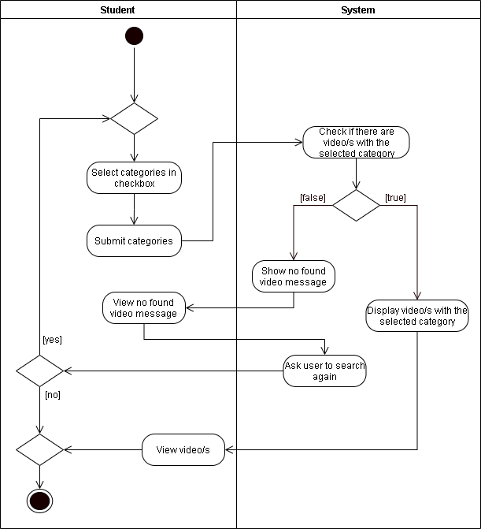

**Figure 21. Activity Diagram for Searching Video by Category**

Figure 21 shows the Activity diagram for searching video by category. The student may input the categories or keywords on the search bar, if there are videos found, the system will display the videos that matches the input and can now view those videos. If not, the system will show that there are no videos found and the student can either search again or terminate the action.

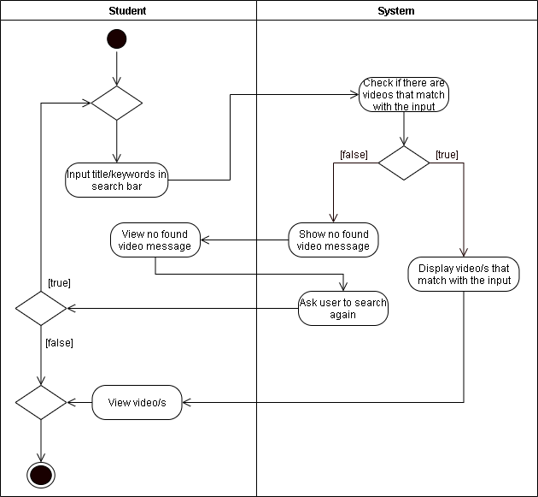

**Figure 22. Activity Diagram for Searching Video by Title**

Figure 22 shows the Activity diagram for searching video by title. The student may input the title or keywords on the search bar, if there are videos found, the system will show the videos that matches the input and can now view those videos. If not, the system will show that there are no videos found and the student can either search again or terminate the action.

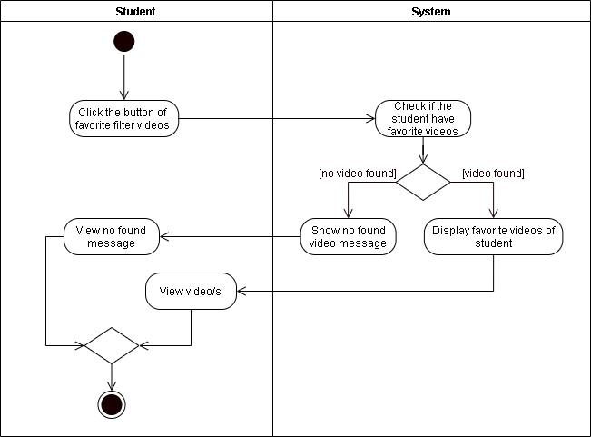

**Figure 23. Activity Diagram for Filtering Favorite Videos**

Figure 23 shows the Activity diagram for filtering favorite videos. The student will click the button of the favorite filter videos, if there are videos found, the system will display the videos that matches the favorites of the student and can now view the video. If not, the system will show that there are no videos found.

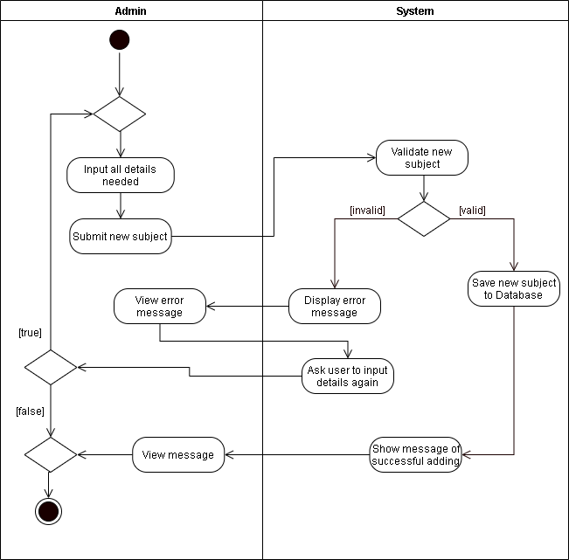

**Figure 24. Activity Diagram for Adding a Subject**

Figure 24 shows the Activity diagram for adding a subject. The admin will input all the details needed for submitting a new subject, after completing the details, the system will validate new subject. If the new subject is valid, it will now be saved to the database. Otherwise, the system will show an error message and will be asked to recreate the process of adding subject or terminate the action.

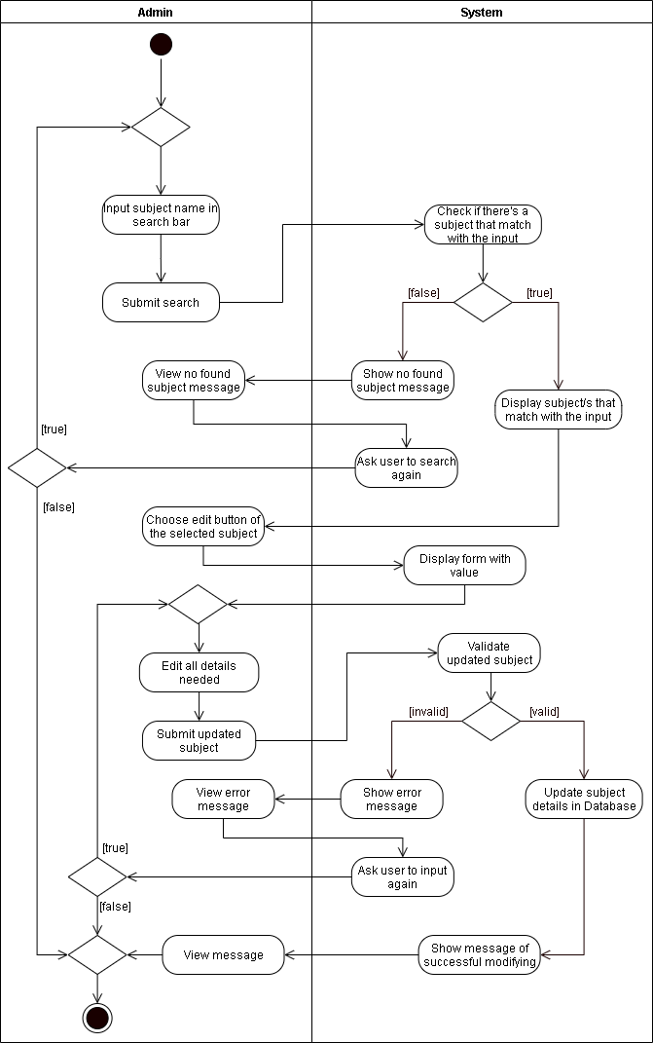

**Figure 25. Activity Diagram for Editing a Subject**

Figure 25 shows the Activity diagram for editing a subject. The admin will input subject name in the search bar, if there is a subject found, the system will display the subjects that matches the input and if not, the system will show an error message. Next, the admin will select the edit button on the selected subject that has a display form with values. After completing the form, the system will now validate the updated subject. If the updated subject is valid, it will now update the details in the database. Otherwise, the system will show an error message and will be asked to recreate the process of editing subject or terminate the action.

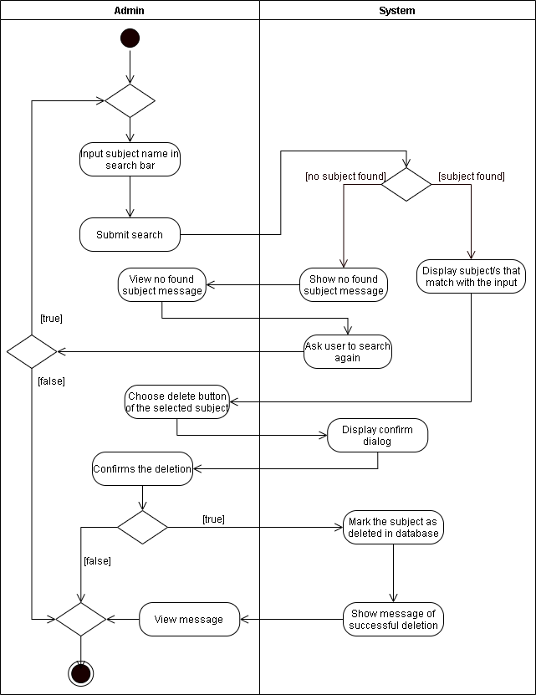

**Figure 26. Activity Diagram for Deleting a Subject**

Figure 26 shows the Activity diagram for deleting a subject. The admin will input the subject name in the search bar, if there is a subject found, the system will display the subjects that matches the input and if not, the system will display an error message. Next, the admin will select the delete button on the selected subject. The system will ask for confirmation whether to delete the subject or not. If the admin confirms, it will now be marked as deleted in the database.

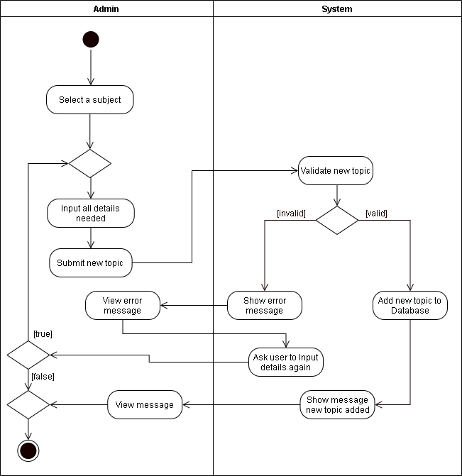

**Figure 27. Activity Diagram for Adding a Topic**

Figure 27 shows the Activity diagram for adding a topic. The admin will select a subject they will add a topic on.Then, the admin will input all the details needed for submitting a new topic, after completing the details, the system will validate the new topic. If the new topic is valid, it will now be saved to the database. Otherwise, the system will display an error message and will ask to recreate the process of adding topic or not.

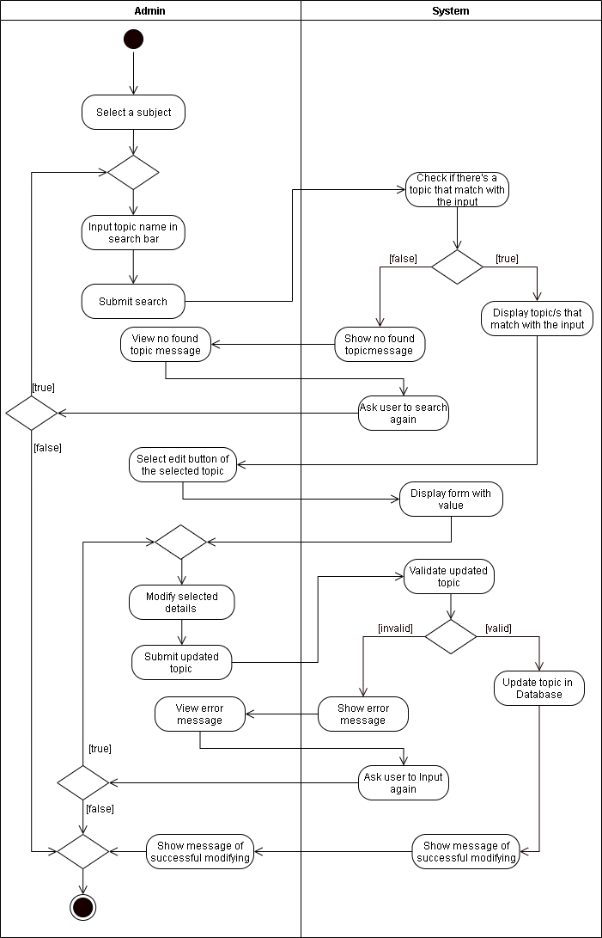

**Figure 28. Activity Diagram for Editing a Topic**

Figure 28 shows the Activity diagram for editing a topic. The admin will select a subject they will edit a topic on. The admin will input the topic name in the search bar, if there is a topic found, the system will display the topic that matches the input and if not, the system will display an error message. Next, the admin will select the edit button on the selected topic that has display form with values. After completing the form, the system will now validate the updated topic. If the updated topic is valid, it will now update the details in the database. Otherwise, the system will show an error message and will ask whether to recreate the process of editing topic or terminate the action.

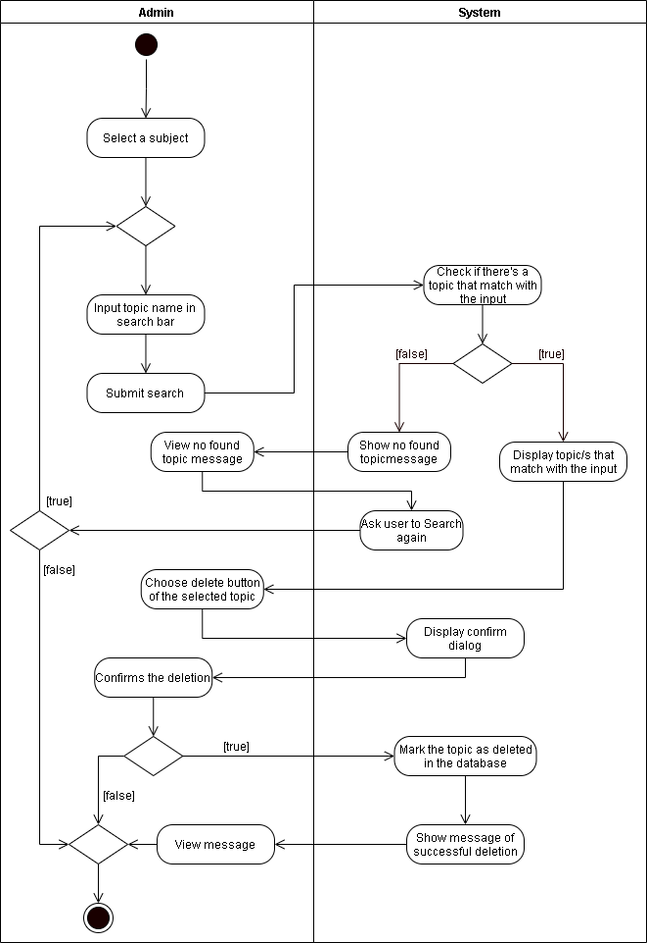

**Figure 29. Activity Diagram for Deleting a Topic**

Figure 29 shows the Activity diagram for deleting a topic. The admin will select a subject where they will delete a topic. The admin will input the topic name in the search bar, if there is a topic found, the system will display the topic that matches the input and if not, the system will display an error message. Next, the admin will select the delete button of the selected topic that will display a prompt. The system will ask for confirmation whether to delete the topic or not. If the admin confirms, it will now be marked as deleted in the database.

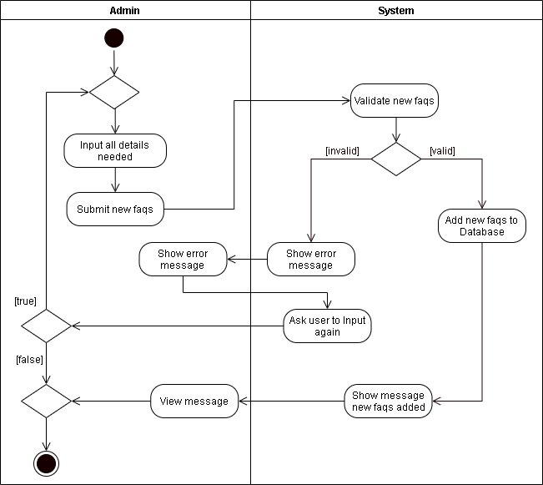  
**Figure 30. Activity Diagram for Adding of FAQs**

Figure 30 shows the Activity diagram for adding of FAQs. The admin will input all the details needed for posting FAQs, after completing the details, the system will proceed to saving FAQs. If the processing succeeds, it will now be added to the database. Otherwise, the system will show an error message and will be asked to recreate the process of adding FAQs or terminate the action.

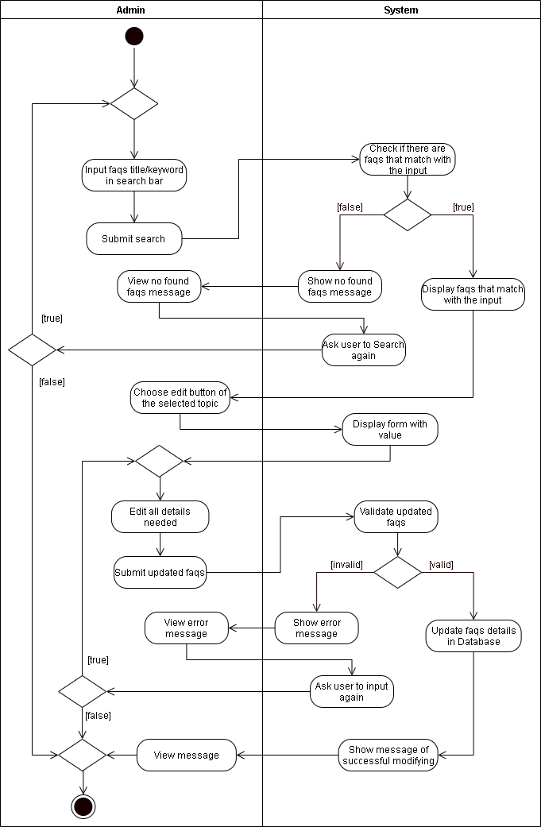

**Figure 31. Activity Diagram for Editing FAQs**

Figure 31 shows the Activity diagram for editing of faqs. The admin will input the FAQs title or keyword in the search bar, if there is a FAQs found, the system will display the FAQs that matches the input and if not, the system will show that there are no FAQs found. Next, there will be an edit button of the selected FAQs that has display form with values. After completing the form, the system will process updating FAQs. If the FAQs is valid, it will now update the details in the database. Otherwise, the system will show an error message and will be asked to recreate the process of editing FAQs or terminate the action.

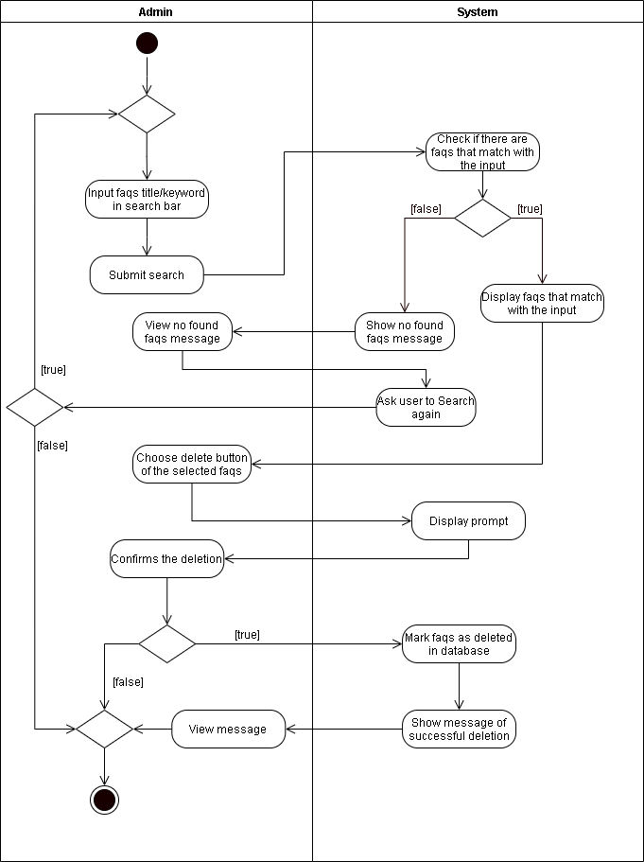.

**Figure 32. Activity Diagram for Deleting FAQs**

Figure 32 shows the Activity diagram for deleting of FAQs. The admin will input the FAQs title or keyword in the search bar, if there is a FAQs found, the system will display the FAQs that matches the input and if not, the system will show that there are no FAQs found. Next, the admin will select the delete button of the selected FAQs that will display a prompt. The system will ask for confirmation whether to delete the FAQs or not. If the admin confirms, it will now be marked as deleted in the database.

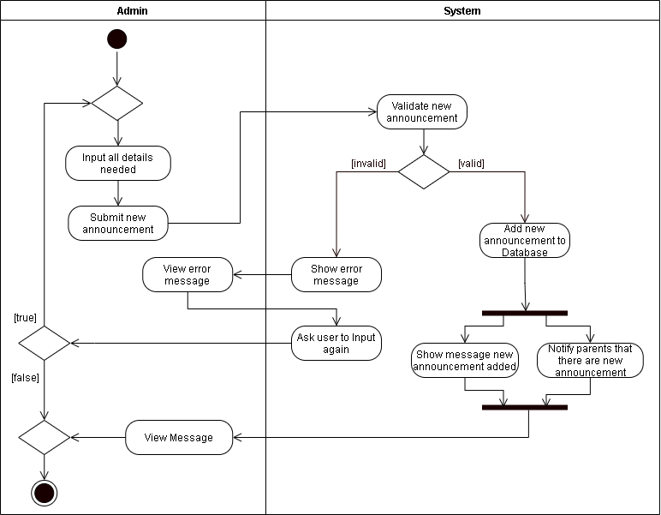

**Figure 33. Activity Diagram for Adding an Announcement**

Figure 33 shows the Activity diagram for adding an announcement. The admin will input all the details needed for posting announcement, after completing the details, the system will proceed to saving announcement. If the processing succeeds, it will now be added to the database and will show a notification on the parents account. Otherwise, the system will show an error message and will be asked to recreate the process of adding an announcement or terminate the action.

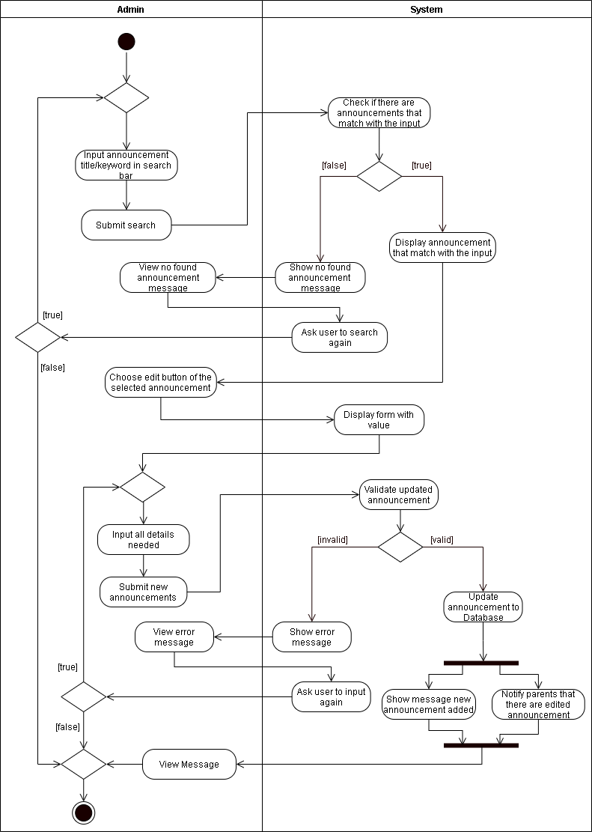

**Figure 34. Activity Diagram for Editing an Announcement**

Figure 34 shows the Activity diagram for editing an announcement. The admin will input the announcement title or keyword in the search bar, if there is an announcement found, the system will display the announcement that matches the input and if not, the system will show that there are no announcements found. Next, the admin will select the edit button on the selected announcement that has a display form with values. After completing the form, the system will proceed to updating the announcement. If the processing succeeds, it will now update the details in the database and will show a notification on the parents account. Otherwise, the system will show an error message and will be asked to recreate the process of editing announcement or terminate the action.

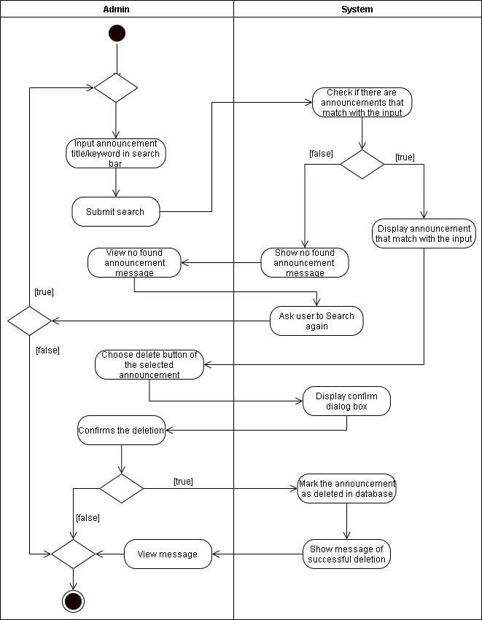

**Figure 35. Activity Diagram for Deleting an Announcement**

Figure 35 shows the Activity diagram for deleting an announcement. The admin will input announcement title or keyword in the search bar, if there is an announcement found, the system will display the announcement that matches the input and if not, the system will show that there are no announcements found. Next, the admin will select the delete button of the selected announcement that will display a prompt. The system will ask for confirmation whether to delete the announcement or not. If the admin confirms, it will now be marked as deleted in the database.

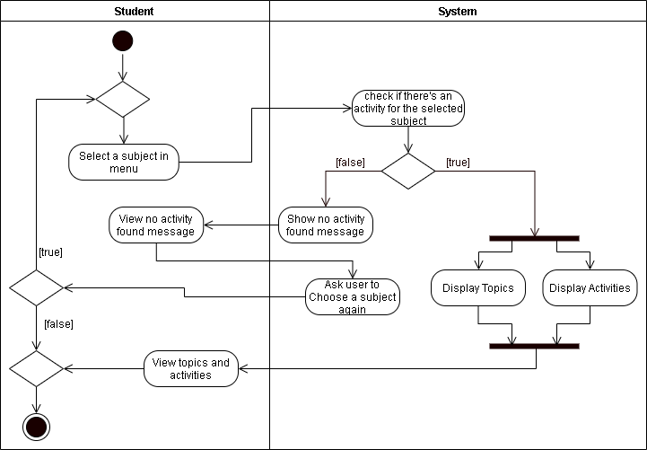

**Figure 36. Activity Diagram for Opening a Subject**

Figure 36 shows the diagram for opening a subject. The student will open a subject in menu, the system will check if there’s an activity for the subject. If it is true, the system will proceed in displaying topics and activities. Otherwise, the system will show there are no topics or activities found and will need to recreate the process of selecting subjects.

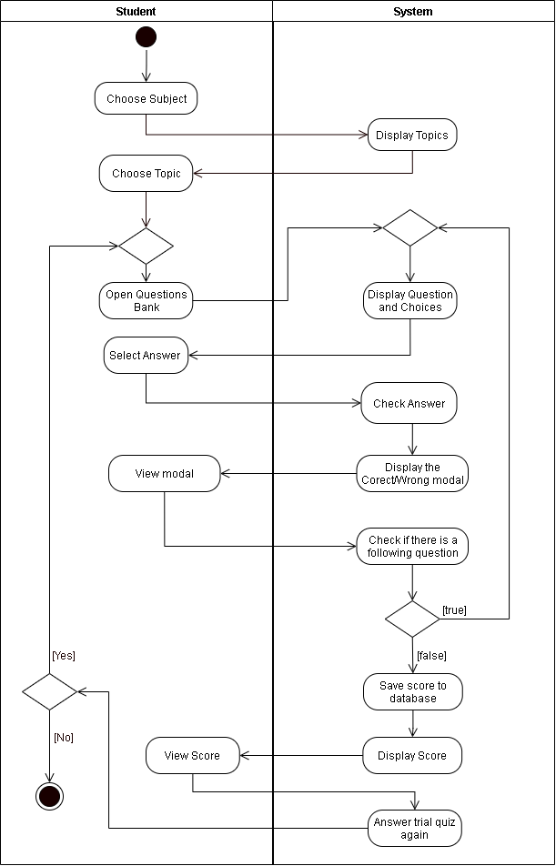

**Figure 37. Activity Diagram for Taking Trial Quizzes**

Figure 37 shows the diagram for taking trial quiz. The student will select the subject. Next, the student will proceed on choosing a topic. Then, the system will display various activities that student can answer and then the system will show a correct or wrong notification. After completing the answer, the student can check if there is a following question or just proceed in submitting the response. After submitting, the system will display the score and the score can be viewed by the student.

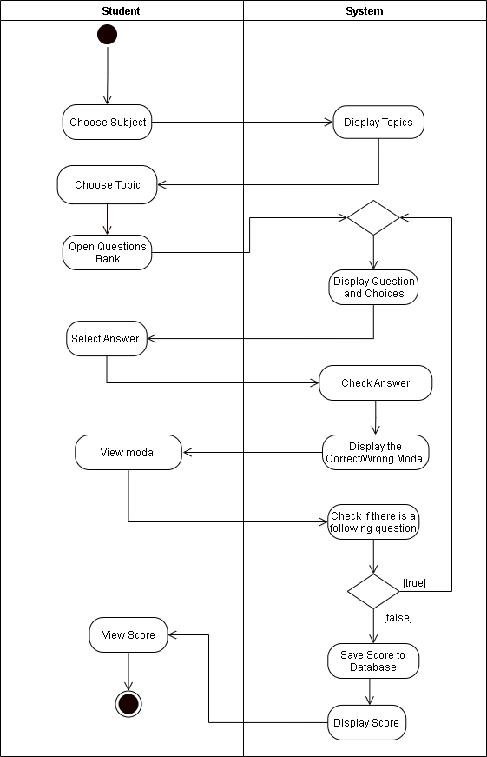

**Figure 38. Activity Diagram for Taking Assessments**

Figure 38 shows the diagram for taking of assessment. The student will select the subject. Then, the system will display various assessmemnt tasks that student can answer and then the system will show a correct or wrong notification. After completing the answer, the student can check if there is a following question or just proceed in submitting the response. After submitting, the system will save the score to the database and the score can be viewed by the student.

In the Implement phase, the researchers will begin to fulfill the activities planned in the previous phase. The researchers will have a time alotted for finishing each activity.

In the Review and Retrospect phase, the finished features from doing an activity will be reviewed and if there are tasks not finished in time from that activity, it will be included in the next activity. The researchers will also reflect upon the challenges from the previous activities and improve on the future activities to be done.

The Release phase is when the system is completely done and the researchers are ready to send it over to the client. The researchers will also reflect upon the challenges in the whole development process that can be improved on the future projects.

**References**

[1] D. N. Arnold, “Computer-Aided Instruction” *Microsoft Encarta Online Encyclopedia*, 2000. [Online]. Available: <http://www-users.math.umn.edu/~arnold//papers/cai.pdf>

[2] M. Palatino, “Are Schools in the Philippines Ready to Open in a Pandemic?,” *The Diplomat*, August 19, 2020. [Online]. Available: <https://thediplomat.com/2020/08/are-schools-in-the-philippines-ready-to-open-in-a-pandemic/>

[3] National Institute for Early Education Research, “*Preschoolers Continue to Lose Learning Opportunities from Pandemic*” February 24, 2021. [Online]. Available: https://nieer.org/press-release/preschoolers-continue-to-lose-learning-opportunities-from-

pandemic?fbclid=IwAR1JyQ2oHTimLtSz5e4bcA3lzUotwuRtmB9picL_UahZMxg3hvinPmAOfqc

[4] K. Schwaber and J. Sutherland, “The Scrum Guide,” *Creative Commons Corporation*, November 2020

[5] Wikipedia, “*Cabuyao*,” May 2016, [Online]. Available: <https://en.wikipedia.org/wiki/Cabuyao>

[6] Department of Education, “*Historical Perspective of the Philippine Educational System*,” n.d. [Online] Available: <https://www.deped.gov.ph/about-deped/history/>

[7] Commission on Higher Education, “*CHED K to 12 Ttransition Program*”, n.d. [Online] Available: <https://ched.gov.ph/k-12-project-management-unit/>

[8] S. Y. Balansag, “*Improvement of the Teaching Style. From Traditional Teacher-Centered to Student-Centered Teaching Style*,” Munich, Germany, Grin Verlag, 2019, p. 2

[9] A. Craddock, “*Philippines K-12 Reforms Poised to Transform Higher Education System*,” June 7, 2016. [Online] Available: <https://wenr.wes.org/2016/06/philippines-k-12-reforms-poised-transform-higher-education-student-mobility>

[10] College of Arts and Technology, *“2018 Review and Updates on the K-12 Curriculum in the Philippines,”* January 5, 2018. [Online] Available: <https://www.ciit.edu.ph/k-12-curriculum-in-the-philippines/>.

[11] M. A. Alsubaie, Journal of Education and Practice, *“Curriculum Development: Teacher Involvement in Curriculum Development.”* Vol.7, No.9, pp. 107, 2016

[12] J. Gayo and N. Yap, “Coronavirus Pandemic 2020: Everything You Need to Know” *Philippine Daily Inquirer*, March 19, 2020. [Online] Available: <https://newsinfo.inquirer.net/1243479/coronavirus-pandemic-2020-everything-you-need-to-know>

[13] UNESCO, *“COVID-19 - Education: From disruption to recovery,”* 2020. [Online] Available: <https://en.unesco.org/covid19/educationresponse>

[14] J. Crawford et al., "COVID-19: 20 countries' higher education intra-period digital pedagogy responses,” *Journal of Applied Learning & Teaching*, vol.3, no.1, 2020

[15] W. Bao, ‘COVID-19 and online teaching in higher education: A case study of Peking University,” *Wiley*, vol. 2, Issue 2, March 2020

[16] B. Yıldırım, “Preschool Education in Turkey During the Covid-19 Pandemic: A Phenomenological Study,” *Early Childhood Education Journal*, 2021.

[17] S. Burgess & H. H. Sievertsen, *“Schools, skills, and learning: The impact of COVID-19 on education.”*  April 1, 2020 [Online] Available: <https://voxeu.org/article/impact-covid-19-education>

[18] R. M. Viner et al., “School closure and management practices during coronavirus outbreaks including COVID-19: A rapid systematic review’. *The Lancet Child & Adolescent Health*, vol. 4, Issue 5, pp. 397–404, 2020. [Online] Available: <https://www.thelancet.com/journals/lanchi/article/PIIS2352-4642(20)30095-X/fulltext>

[19] M. M. McClelland, A. C. Acock, A. Piccinin, S. A. Rhea, and M. C. Stallings,"Relations between preschool attention span-persistence and age 25 educational outcomes," *Early Childhood Research Quarterly*, vol. 28, pp. 314-324, 2013. [Online] Available: <https://www.academia.edu/29221970/>.

[20] A.Cheok, H. Ishii, J. Osada, O. N. N. Fernando, and T. Merritt," Interactive Play and Learning for Children," *Hindawi Publishing Corporation*, 2008.

[21] M. E. P. Seligman,R. M. Ernst,J. Gillham,K. Reivich and M. Linkins, "Positive education: positive psychology and classroom interventions," *Oxford Review of Education*, vol. 35, no. 3, pp. 293-311, May 2009. [Abstract] Available: Taylor and Francis Online, <https://www.tandfonline.com/doi/abs/10.1080/03054980902934563>.

[22] P. L. N. Randima Rajapaksha and P. R. D. Chathurika, "Problems Faced by Preschool Teachers When Using Teaching Aids in the Teaching Learning Process," *International Journal of Multidisciplinary Studies*,vol. 2, no.1, pp. 97 - 109, 2015. [Online] Available: Scholar Bank, <http://dr.lib.sjp.ac.lk/>.

[23] R. Charlesworth, "Understanding Child Development".C*engage Learning*, pp. 7, 2016.

[24] S.Verma, N. Suman, P. Verma. "Effect of electronic gadgets on cognitive milestones of children below 2 years of age," *International Archives of Integrated Medicine*, vol. 5, no. 6, pp. 52-54, 2018.

[25] T. J. Pardue, "Child-Directed Learning in Varying Contexts: An Examination of Preschools in the Philippines" (2020). *MSU Graduate Theses*. 3581. <https://bearworks.missouristate.edu/theses/3581>

[26] J. Diaz, M. Magalang, J. Villafuerte, C. Ronia and M. Pagaduan, “Children’s Learning Through Play: Perspectives and Practices of Public School Early Childhood Educators,” *6th International Scholars Conference*, Oct 2018. [Abstract] Available: <http://web1.aup.edu.ph/6isc/childrens-learning-through-play-perspectives-and-practices-of-public-school-early-childhood-educators/>.

[27] K. Cherry, “What Are Piaget's Four Stages of Development?,” *Verywell Mind*, 31-Mar-2020. [Online]. Available: https://www.verywellmind.com/piagets-stages-of-cognitive-development-2795457. [Accessed: 14-May-2021].

[28] E. Delas Peñas, *“Challenges of Online Learning vs Traditional Learning for Students”*, August 19, 2020. [Online] Available: <https://covid19.sdsnyouthph.org/article.php?id=51>

[29] Sixth Form, *“Teaching Methods: Traditional Vs Modern”*, July 31, 2017. [Online] Available: <https://sixthform.stephenperse.com/blog/?pid=458&nid=45&storyid=4728>

[30] C.D. Francisco and M. C. Barcelona, “Effectiveness of an Online Classroom for Flexible Learning,” *International Journal of Academic Multidisciplinary Research (IJAMR)*, vol. 4, issue 8, August 2020, p. 101. [Online] Available: <https://files.eric.ed.gov/fulltext/ED607990.pdf>

[31] B. Magsambol, “No backing down: Briones says classes will open on August 24 ‘whatever form it is,” *Rappler*, July 16, 2020

[32] M. G. Amadora, “Common Problem that Occur During Online Classes”, *Manila Bulletin*, September 18, 2020

[33] D. Poudel, *“Pros and Cons of Traditional Schools,”* September 26, 2019. [Online] Available: https://honestproscons.com/pros-and-cons-of-traditional-schools/

[34] M. Sundus, “The Impact of using Gadgets on Children”, *Journal of Depression and Anxiety*, vol. 7, issue 1, January 2018. [Online] Available: https://www.longdom.org/open-access/the-impact-of-using-gadgets-on-children-2167-1044-1000296.pdf

[35] C. M. Toquero, “Challenges and Opportunities for Higher Education amid the COVID-19 Pandemic: The Philippine Context,” *Pedagogical Research*, vol. 5, no. 4, 2020.

[36] D. Ruliah, Z. Syahrial, and H. Muchtar, “The Computer Assisted Instruction Model Based on a Combination of Tutorial Model and Drill and Practice Model in the Instructional Design of Database Systems in Information Technology Colleges,” *Universal Journal of Educational Research*, vol. 7, no. 9A, pp. 117–124, 2019.

[37] S. Wahyuni, “Development of Computer Assisted Instruction (CAI) Based Teaching Materials in Junior High School,” *International Journal of Learning and Teaching*, Dec. 2016.

[38] P. K. Owusu and K. Quist-Aphetsi, “Computer Aided Education for Early Childhood: A Focus for Text and Object Identification,”  *International Conference on Cyber Security and Internet of Things (ICSIoT)*, 2019.

[39] J. Scott, “Understanding the Pros and Cons: What Is Computer Assisted Learning?,” *General Educator Blog*, 24-Jan-2021. [Online]. Available: https://www.fluentu.com/blog/educator/what-is-computer-assisted-learning-2/.

[40] R. Sharma, “Computer Assisted Learning – A Study Vol. 4, Issue 2,” *International Journal of Advanced Research in Education & Technology (IJARET)*, 2017. [Online]. Available: http://www.ijaret.com/vol-4-issue-2/.

[41] Lexia Learning, *“Adjusting to the New Normal,”* 18-May-2020. [Online]. Available: https://www.lexialearning.com/blog/adjusting-new-normal.

[42] M. Saldon-Eder, L. J. Raboy, P. Rojas, and M. G. Empasis, “Computer Aided Instruction for Preschoolers In Mathematics,” Proceedings Journal of Education, *Psychology and Social Science Research*, 2014.

[43] H. Shamir, K. Feehan, and E. Yoder, “Does CAI Improve Early Math Skills?,” *Proceedings of the 9th International Conference on Computer Supported Education*, 2017.

[44] D. G. D. Funcion, L. J. B. Caluza, J. C. Cinco, R. L. Verecio, M. A. Gotardo, L. , A. Quisumbing, V. Marmita, L. Ripalda, and T. A. Ticoy, “*Development and Integration of Waray Instruction in Teaching Nursery Rhymes,”* vol. 7, pp. 1–8, Dec. 2016.

[45] C. Pfeiffer, A. Jabbar, *"Adaptive e-Learning: Emerging Digital Tools for Teaching Parasitology,"* vol. 35, no. 4, pp. 270-274, April, 2019. [Abstract]. Available: Science Direct, https://www.sciencedirect.com/science/article/abs/pii/S1471492219300212

[46] S. Vanbecelaere, et al., "The effectiveness of adaptive versus non-adaptive learning with digital educational games," *Wiley*,vol.36, no. 4, pp. 502-513, December, 2019. [Abstract]. Available: Wiley Online Library, https://onlinelibrary.wiley.com/doi/abs/10.1111/jcal.12416

[47] Min Liu, et al., *"Using Data to Understand How to Better Design Adaptive Learning,"* no. 22, pp. 271-298, 2017. [Abstract]. Available: Spring Link, <https://link.springer.com/article/10.1007/s10758-017-9326-z>

[48] I. Etikan and K. Bala, "Sampling and sampling methods," *Biometrics & Biostatistics International Journal,*vol. 5, issue 6, 2017